**Concept Note**

**Reservoir Assessment Tool (RAT) for Lower Mekong Basin**

*Enhancing the capability to monitor water storage changes, water levels, the inflows and outflows of reservoirs to support the decision making related to flood and drought assessment and water resource management in the Lower Mekong Region*

# **Background**

Earth-orbiting satellites and other technological advances have enabled scientists to see the big picture, collecting many different types of information about our planet and its climate on a global scale. This body of data, collected over many years, has the potential to unlock the solutions to better resilience to climate change that is unprecedented and causing sea levels to rise, floods and droughts to occur more frequently, and ecosystems to change dramatically, thus threatening livelihoods. Through a unique partnership between the [U.S. Agency for International Development (USAID)](https://www.usaid.gov/) and the [U.S. National Aeronautics and Space Agency (NASA)](https://www.nasa.gov/), SERVIR-Mekong is harnessing such space technology and open data to help address development challenges related to a changing climate.

SERVIR-Mekong works in partnership with leading regional organizations to help the five countries in the Lower Mekong Region use information provided by Earth observing satellites and geospatial technologies to manage climate risks. The region includes Cambodia, Lao PDR, Myanmar (Burma), Thailand and Vietnam. The [Asian Disaster Preparedness Center (ADPC)](http://www.adpc.net/igo/?), a recognized leader in strengthening disaster resilience in Asia, is the prime implementer for SERVIR-Mekong. Three other consortium partners, [Spatial Informatics Group (SIG)](http://sig-gis.com/), [Stockholm Environment Institute (SEI)](https://www.sei-international.org/) and [Deltares](https://www.deltares.nl/en/), assist in implementing the SERVIR-Mekong program and bring exceptional capabilities to help deliver services to the region.

In 2019, the Mekong River Commission (MRC) Secretariat has started to implement its initiative in reinvigorating its data, modeling and information systems to provide enhanced and timely information to the public and MRC member countries. These include integrated database and data management systems, data quality control and assurance process, document management system, modeling tools, and river monitoring and forecasting information and communication. The main purpose is to provide faster reactions to address emerging changes, such as climate change or sudden water release from reservoirs in the Lancang-Mekong river basin, track basin state and development, and strengthen one of the MRC’s key roles as the regional knowledge hub. To date, the MRC’s governing body, Joint Committee, has approved the work’s design concept that assesses the current state of data and information systems in house and proposes what needs to be done at which stage. The concept is now being used to inform the Organization’s Strategic Plan for 2021-2025 and its Basin Development Strategy for 2021-2030 for funding support and future implementation.

In 2020, The MRC had launched a revitalized online data service platform that assembles, analyses, and visualizes data about the health and condition of the Mekong River. The MRC’s Data Portal aggregates and visualizes data collected by the MRC’s river basin water monitoring networks and other official data from the four MRC member countries – Cambodia, Lao PDR, Thailand and Viet Nam – and its upstream dialogue partner, China. The improved MRC’s Data Portal is a part of a larger exercise the Commission has been doing under the above-mentioned initiative to reinvigorate its data, information, modelling, forecasting and communication systems.

The MRC and its member countries realize that the water storage reservoirs in China and other key reservoirs in LMB have an important impact on downstream flows, and incorporating the real-time operation of these reservoirs into the MRC’s Decision Support Systems (DSSs) would help to better monitor the changes and manage both floods and droughts. The Design Concept (endorsed by the Council in late 2019) has also identified a need to update/upgrade current MRC’s modelling capability to ‘operational models’ to address emerging changes on the river and in the basin for a quick reaction and early warning (e.g., rapid fluctuation of water level on the mainstream, hydropower operations, reservoir optimization). Currently, the MRC is working to update the baseline data of the MRC’s Decision Framework (DSF), it is not ready to be converted or transformed into an operational or on-line platform yet.

Furthermore, the MRC’s Drought Management Strategy (DMS) 2020-2025 recommends reservoir levels as another essential element to be monitored as it is missing from the current indicators from the operational drought monitoring system of the Regional Flood and Drought Management (RFDMC) of the MRC. This is because reservoirs play an important role in water resources planning during severe and prolonged drought periods when rainfall is inadequate and water levels are considerably low. The DMS has proposed to install monitoring sensors at some major reservoirs to obtain near-real time information that will be connected to the existing monitoring work of the member countries. The MRC-RFDMC expects to provide technical assistance and support to countries by this near-real time information on reservoir level in the drought disaster areas especially during the emergency situation when needed in drought assessment, water resources analysis and drought mitigation planning.

Since satellite observations and advancements in information technology now present a unique opportunity to overcome the traditional limitations of reservoir monitoring. A Reservoir Assessment Tool ([RAT](http://depts.washington.edu/saswe/rat_beta)), developed by University of Washington in collaboration with University of Houston and the SERVIR-Mekong program, is one such global reservoir monitoring framework (Biswas et al., 2021). The RAT framework was developed as an online tool for near-real time monitoring and impact analysis of existing and planned reservoirs based on publicly available and global satellite observations.

The RAT framework uses a mass balance approach to monitor 1598 reservoirs in South America, Africa, and the South-East Asia region. About 2 TB/day of data are processed in the cloud for the 1598 reservoirs. The RAT-simulated streamflow (inflow) has been validated in 25 river basins and the storage change was validated against in-situ data of 77 reservoirs. The framework was able to capture reservoir storage change realistically for more than 75% of these reservoirs. Outflow and inferred rule curves have been validated against select reservoirs in Asia (Kaptai in Bangladesh; Ubol Ratana and Sirindhorn in Thailand) and USA (Hungry Horse and Oroville in USA). The RAT tool, which is open-source and uses advancements of information technology, Big Data and distributed computing in the cloud, can now be used to study existing and planned reservoirs for hydrologic impact and operating pattern for short- and long-term decision making and policy analysis. It should be noted that RAT monitors reservoirs at bi-weekly timescales. For catastrophes, it can only monitor 'risk' of overtopping. It is not able yet to inform anyone of imminent hydrologic failure or structural failure. RAT is designed more to address how much water the reservoirs are holding, releasing, diverting and how they typically operate in a world where such data is hard to come by due to transboundary challenges. Brief methodology of RAT is provided in Annex.

In addition, reservoir water level changes can be directly obtained from satellite radar altimetry (Okeowo et al., 2017). Satellite altimetry is a mature technique that can directly provide inland water level changes with accuracies of a few centimeters to decimeters, largely depending on the size of the water bodies. However, because it is a 1-D profiling instrument, the water levels can be obtained only if the water body has an altimeter overpass. Currently, there is a suite of operating altimeters including Jason-3 (10-day repeat, 2016 – present), Sentinel-3A (27-day repeat, 2016 – present), Sentinel-3B (27-day repeat, 2018 – present), and Sentinel-6 (10-day repeat, 2021 – present), in addition to several historical ones (TOPEX, Jason-1/2, Envisat, SARAL, etc). An example of water level changes derived from NASA’s Jason-2 altimetry over the Nam Ngum 2 reservoir in Laos is shown in Annex.

The benefits of using the RAT/altimetry tool in LMB include, but not limited to, the followings:

* the MRC and MCs will receive great benefits for managing natural resources;
* Near Real-time (bi-weekly) reservoir behavior and reservoir operating rules based on long term records are made available to the public, which can be helpful in data-scarce or data restricted regions like some parts of the Mekong Basin;
* It will help MRC and MCs derive a global picture of reservoir monitoring, how they are being operated, and how they are impacting natural river flow and its variability as a function of climate, hydrologic regime, and socio-economic indicators;
* With further improvements in hydrological modeling using locally available ground observations, this framework can be used in local, regional, and global scale operational water resources management with its near-real-time (bi-weekly) data availability with higher accuracy;
* This framework also facilitates the feasibility study of proposed/planned dams. It can be used to estimate the future reservoir capacity and the inflow availability at any location, which is useful in optimizing reservoir benefits;
* This tool provides future possibilities to study the impact of harnessing hydropower on river temperature, greenhouse gas emissions, aquatic habitats, land-use and landcover change, and agriculture practices;
* This tool can be used to minimize the conflict between riparian countries including China as it can be considered an unbiased tool to all the parties and provide data needed to drive a fair and transparent water-sharing agreement.
* The information obtained from the RAT could also support the implementation of MRC’s Procedures (PDIES, PMFM, PWUM, PNPCA) and monitoring/forecasting activities of the MRC’s Regional Flood and Drought Management Centre (RFDMC).

# **Objective**

# The ultimate goal of the service on Reservoir Assessment Tool (RAT) under the SERVIR-Mekong programme is to support the MRC and its member countries by enhancing the current flood and drought assessment capability through utilizing/customizing an existing-shared reservoir monitoring platform to support the MRC’s Drought Management Strategy (DMS) 2020-2025, transboundary integrated river basin planning and decision-making as well as water resource development and management in the Lower Mekong Basin.

# **Scopes of Service**

* Work closely with MRC and countries to refine/fine-tune the existing tool to meet the essential needs of MRC based on available information/data which should be within the limitation/constraints of the existing tool. This includes selecting key reservoirs which will be classified based on the reservoir’s size and its important to flood and drought assessment to be displayed in the tools;
* Re-calibrate and validate model outputs of RAT (in case additional datasets are provided by MRC);
* Explore and integrate the existing data available within MRC and its member countries to improve the existing RAT (e.g. data/information from hydro-met network, MRC-DSF, FEWS, URBS, FFGS, Drought System);
* Design and develop a frontend web interface of the RAT for Lower Mekong Basin for easy access and ease of usage with close consultation with MRC;
* Develop a database or produce a user friendly on-line reservoir monitoring report (bi-weekly) on information of key reservoirs in the Lower Mekong Basin which could be possibly extracted from the tool (e.g. water level, storage change, inflow, outflow, rule curves) including datasets of modelling (if needed);
* Provide support and engage with the MRC and member countries on operationalizing the improved Reservoir Monitoring System;
* Deliver capacity building programme/trainings for the MRCS and the Member Countries onapproach, methodologies, modelling techniques and assessment of RAT for Lower Mekong Basin;
* Support the MRC to set up RAT in MRC environment (or the MRC data portal) in order to transfer ownership and administration/management responsibility;

# **Expected Outputs**

1. A frontend web interface of Reservoir Assessment Tool (RAT) and operational reservoir monitoring developed for Lower Mekong Basin;
2. Database on information of key reservoirs in the Lower Mekong Basin and model datasets;
3. A user friendly of online reservoir monitoring report with essential elements (can be improved further by MRC)
4. Capacity building programme/trainings for MRC and the Member Countries

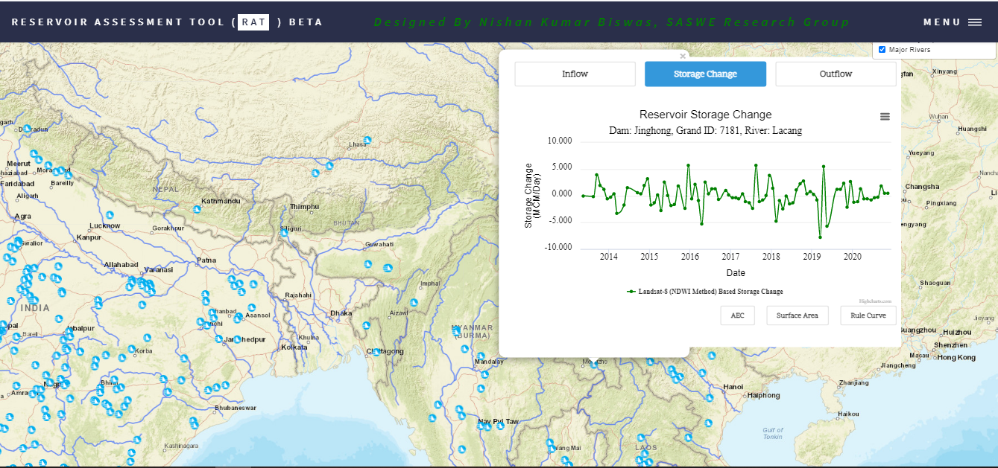

***Figure 1****: An example of frontend web interface of the RAT tool operational framework with the blue reservoir icons showing reservoir locations and the polylines are the river network downloaded from https://www.naturalearthdata.com. The upper right corner of the window allows users to toggle between selections of layers, and available base-maps could be switched from the lower right corner.*

# **Expected Outcomes**

It is expected that the products of RAT would assist/enhance MRC and member countries to understand operating patterns and states of reservoirs which would enable riparian countries to manage water-related hazards such as floods and droughts in order to mitigate any impacts those may arise. The reservoir water levels could be obtained directly from satellite altimetry or derived from the area-elevation curves generated by the tools which would directly contribute to support the determination of reservoir level as a drought index suggested by the DMS. The estimated water availability in the reservoirs could be applied for crop planning as well as to identify any measures to be implemented to alleviate drought it is likely to occur.

The tools might be applied to investigate hydropower cascade operation and quantify any potential impacts on the Mekong mainstream and tributaries that would contribute to guiding water resource planning and reducing the adverse impact on the environment as well as better manage both floods and droughts.

The approach and tools including datasets being developed under this service could also demonstrate how the MRC could explore and collaborate with global data generators/organizations to migrate/connect to their datasets as suggested in the Design Concept (reinvigoration) in order to develop a post processing mechanism or workflow to link to integrated database and monitoring and forecasting in a later stage.

# **Tentative Work Plan**

Planned completion of the proposed objectives

|  |  |  |  |  |  |  |  |  |  |  |  |  |  |
| --- | --- | --- | --- | --- | --- | --- | --- | --- | --- | --- | --- | --- | --- |
| **Service Name** | **Mar**  **2021** | **Apr**  **2021** | **May**  **2021** | **Jun**  **2021** | **Jul**  **2021** | **Aug**  **2021** | **Sep**  **2021** | **Oct**  **2021** | **Nov**  **2021** | **Dec**  **2021** | **Jan 2022** | **Feb 2022** | **Mar 2022** |
| **Water Resources and Hydro-Climatic Disasters Services: Enhancing Reservoir Monitoring and Water Resource Management of the Mekong River Basin** |  |  |  |  |  |  |  |  |  |  |  |  |  |
| **a) Reservoir Assessment Tool (RAT)** |  |  |  |  |  |  |  |  |  |  |  |  |  |
| collect additional data from MRC and identify key reservoirs to be included |  |  |  |  |  |  |  |  |  |  |  |  |  |
| Refine/improve the existing RAT tool with MRCS and re-calibrate and validate model outputs of RAT (in case additional datasets are provided by MRC) |  |  |  |  |  |  |  |  |  |  |  |  |  |
| Design and develop a frontend web interface of RAT for the Mekong Region |  |  |  |  |  |  |  |  |  |  |  |  |  |
| Develop a database or produce a simple version of online reservoir monitoring report |  |  |  |  |  |  |  |  |  |  |  |  |  |
| Provide support and engage with the MRC on operationalizing the improved Reservoir Monitoring System with Mekong member countries |  |  |  |  |  |  |  |  |  |  |  |  |  |
| Support the MRC to set up RAT in MRC environment (MRC portal) |  |  |  |  |  |  |  |  |  |  |  |  |  |
| **Capacity building programme/Trainings and Workshops** |  |  |  |  |  |  |  |  |  |  |  |  |  |
| Consultation meetings/Technical working group with MRC on Reservoir Assessment within LMB |  |  |  |  |  |  |  |  |  |  |  |  |  |
| Training/workshop on potential application of RAT through a demonstrated case including methods: Automatic Area-Elevation Curve Generation and Google Earth Engine (GEE) to map inundated reservoir area for MRC |  |  |  |  |  |  |  |  |  |  |  |  |  |
| Training/workshop on potential application of RAT through a demonstrated case including methods: Automatic Area-Elevation Curve Generation and Google Earth Engine (GEE) to map inundated reservoir area for the Member Countries |  |  |  |  |  |  |  |  |  |  |  |  |  |
| Mekong Regional Symposium on Enhancing Reservoir Monitoring to support flood and drought and Water Resource Management of the Mekong River Basin |  |  |  |  |  |  |  |  |  |  |  |  |  |

# **Role and responsibility**

**SERVIR-Mekong Team (ADPC, SEI, UW, UH)**

* To develop the RAT tools while customizing/tailoring them to meet the requirement of MRCS and countries as much as possible and as appropriate
* To work closely with MRCS and countries to deliver final products to MRCS while ensuring that the tools will run smoothly in MRC environment
* To provide technical support and engage with the MRC and member countries on operationalizing the improved Reservoir Monitoring System
* To provide capacity building/trainings to MRCS and countries both regional and national levels
* To co-organize and facilitate technical working group meeting, regional consultation meetings and technical workshops
* To provide the capacity building trainings to MRCS and the Member countries

**Mekong River Commission Secretariat**

* To work closely with the SRVIR-Mekong Team to develop the tools and deliver final products
* To provide communication support with Member Countries
* To facilitate, support, collect and provide relevant data/information
* To conduct and contribute to calibration and validation of model outputs of RAT
* To organize and facilitate technical working group meeting, regional consultation meetings and technical workshops (if any)

**National Mekong Committees and Line Agencies**

* To collaborate by working closely with SERVIR and MRC on specific tasks such as selecting key reservoirs, model calibration and validation, testing, etc.
* To facilitate, support and provide additional data and information necessary for the development
* To participate the meetings/workshops both national and regional and provide constructive comments
* To organize and facilitate national consultation meetings or workshops (if any)

# **References**

Bonnema, M., Sikder, S., Miao, Y., Chen, X., Hossain, F., Ara Pervin, I., Mahbubur Rahman, S.

M., and Lee, H. ( 2016), Understanding satellite‐based monthly‐to‐seasonal reservoir outflow estimation as a function of hydrologic controls. Water Resources Research, 52(5), 4095–4115. https://doi.org/10.1002/2015WR017830.

Bonnema*, M. and F. Hossain. (2017). Inferring reservoir operating patterns across the Mekong Basin using only space observations,  *Water Resources* Research, vol. 53, pp. 3791–3810, (http://dx.doi.org/10.1002/2016WR019978).

Biswas, N., F. Hossain, M. Bonnema, H. Lee and F. Chishtie (2021), Towards a Global Reservoir Assessment Tool for Predicting Hydrologic Impacts and Operating Patterns of Existing and Planned Reservoirs, Environmental Modeling Software (in presee).

Campbell, I.C. (2009). The Mekong, eds Ian C Campbell, Academic Press, 449.

Chang, Chi-Hung, et al. "A model-aided satellite-altimetry-based flood forecasting system for the Mekong River." *Environmental modelling & software* 112 (2019): 112-127.

eWater. (2019). Design Concept of MRC’s Data, Information, Modelling and Forecasting Systems. etWater Ltd. (Version 1.0)

Gao, H., Birkett, C., & Lettenmaier, D. P. (2012). Global monitoring of large reservoir storage from satellite remote sensing. Water Resources Research, (9), 1–12. https://doi.org/10.1029/2012WR012063.

Hossain, F., M. Bonnema, N. Biswas, S. Ahmad, B. Duong, and N. D. Luong (2019), When floods cross borders, satellite data can help, Eos, 100, https://doi.org/10.1029/2019EO115775.

Hossain, F., S. Sikder, N. Biswas, H. Lee, N.D Luong, N.H. Hiep, B. D. Duong and D. Long (2017) Predicting Water Availability of the Regulated Mekong River Basin Using Satellite Observations and a Physical Model, Asian Journal of Water and Environmental Pollution, 14(3), pp. 39-48.

Markert, K.N., S.T. Pulla, H. Lee, A.M. Markert, E.R. Anderson, M.A. Okeowo, and A.S. Limaye (2019), AltEx: An open source web application and toolkit for accessing and exploring altimetry datasets, Environmental Modelling & Software, 117, 164-175.

MRC. (2019). Drought Management Strategy for the Lower Mekong Basin 2020-2025. Vientiane. Mekong River Commission Secretariat.

Okeowo, M., H. Lee, F. Hossain and A. Getirana (2017), Automated generation of lakes and reservoirs water elevation changes from satellite radar altimetry, IEEE Journal of Selected Topics in Applied Earth Observations and Remote Sensing, 10, 3465-3481.

**Annex: Reservoir Assessment Tool (RAT)**

**Dataset**

The land elevation dataset used in this study was the Shuttle Radar Topography Mission (SRTM) 30 m resolution Digital Elevation Model (DEM) (Hennig et al., 2001). Three sensors were used to derive water extent area time-series; those were

* USGS Landsat 8 Collection 1 Tier 1 and Real-Time data Raw Scenes,
* Sentinel-1 SAR GRID: C-band Synthetic Aperture Radar Ground Range Detected, and
* Sentinel-2 MSI: Multispectral Instrument, Level-1C.

In the gridded hydrological model, FAO Harmonized World Soil Database (Nachtergaele et al., 2009), USGS Global Land Cover Characteristics (GLCC) Land Cover Database (Geological Survey, 1997) were used as the land surface parameters. In order to get the meteorological forcing for the hydrological model, CHIRPS precipitation (Funk et al., 2015), maximum and minimum temperature, and average wind speed at 10m height from NOAA NCEP/Climate Prediction Center were used in this study. For routing the hydrological model outputs, global flow direction at 1/16 degree spatial resolution (Wu et al. 2011) was used.

**Overview and reservoir mass balance approach used in RAT framework**

In this study, the satellite-based remote sensing data were used to estimate the reservoir mass balance equation (1).

𝑂 = 𝐼 - 𝐸 - 𝛥𝑆 ----------------------------------- (1)

Where O = Outflow, I = inflow, E = Evaporative loss, and ΔS = Storage change. In this study, the term “outflow” was used to also include parallel diversion and other consumptive use. The reservoir surface water extent areas At-1 and At in figure 2 were extracted from visible/NIR imageries, corresponding heights ht-1 and ht were extracted using Area-Elevation Curve (AEC), and finally, ΔS was calculated using equation (2). Details about the AEC development are discussed in section 3.4.

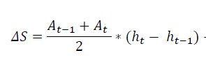

------------------------ (2)

First, the area of interest (AOI) of any reservoir is defined by following a reservoir size-dependent buffer distance shown in **table 1**. The AOI is used to clip satellite observations for preparing the area-elevation relationship and to extract the time series of surface water area. Storage change of any reservoir can be computed using reservoir water surface area/elevation time series and area-elevation relationship shown in **figure 1.** This is a widely-used technique reported to yield acceptable skill (Bonnema et al., 2016; Crétaux et al., 2011; Gao, 2015; Gao et al., 2012). Meteorological observations and land surface parameters are forced into a hydrological model to derive reservoir inflow. The inflow, evaporation, and storage change can then be used to infer the reservoir outflow using mass balance. Details about specific methods are discussed in sections 3.3, 3.4 and 3.5.

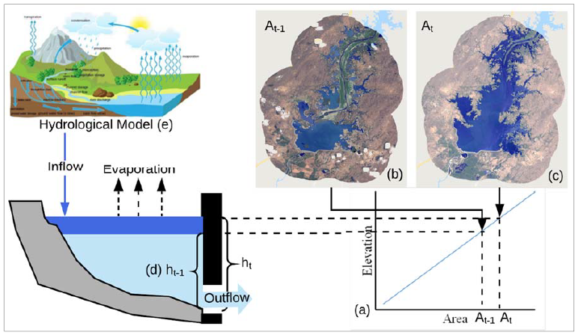

**Figure 1**: Concept of satellite data-based mass balance for reservoir monitoring. The different reservoir parameters and corresponding satellite datasets used are, a) The Area-Elevation relationship Curve (AEC) derived from SRTM, b) and c) are from visible/NIR satellite imagery, d) was derived from AEC and e) from satellite-based meteorological observations. (*After Biswas et al. 2021, Environmental Modeling and Software)*

**Storage change calculation**

The method followed in this study to calculate storage change in individual reservoirs is shown in figure 2. Major components mentioned in the mass balance equation are 1) AOI generation, 2) AEC extraction, 3) water extent area time-series processing, 4) storage change calculation, 5) simulation of reservoir inflow from the hydrological model and evaporation from the reservoir, and 6) reservoir outflow calculation. Except for hydrologic modeling (items 5 and 6), all components are executed in the cloud using Google Earth Engine (GEE) to minimize internet bandwidth of downloading large datasets and leverage massively-distributed computing. GEE has been extensively used in the different large-scale hydrological analyses (Biswas et al., 2019; Pekel et al., 2016; Zhao & Gao, 2018), which offers highly advanced and previously unachievable computational possibilities.

**Area-elevation curve extraction**

Using the delineated AOI mentioned in section 3.2 and SRTM DEM data, the Area Elevation Curve (AEC) was derived in two steps. Firstly, the AOI of the selected reservoir was used to clip the SRTM DEM. The SRTM DEM elevation was used to generate the area-elevation relationship, which is valid for the elevation above the water surface at the time of the SRTM overpass (which was in February 2000). Secondly, the relationship developed in the first step was extrapolated to the near-zero surface area in order to generate a complete virtual area-elevation relationship for the elevation lower than the SRTM observed water surface. Finally, these two area elevation relationships were merged to create the complete area-elevation curve. The whole methodology of AEC-Development is explained in **figure 2**.

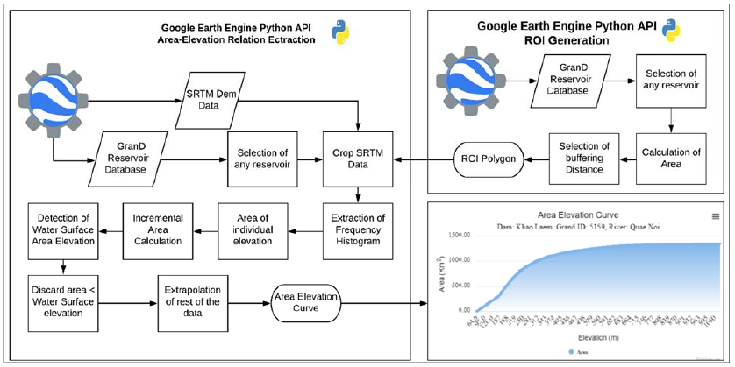

**Figure 2:** Reservoir AOI polygon delineation and AEC curve extraction procedure. (Souce: Kumar Biswas & Hossain, 2017.)

**Surface water area extraction**

All imagery scenes are filtered using a predefined date window and the AOI polygon, then clipped using the AOI. In the case of Sentinel 2 and Landsat, cloudy pixels were removed from the AOI of the scene. The area of the scenes was calculated and filtered out if the area is less than 80% of the AOI (after the removal of the cloudy and partially covered scene). In the case of Sentinel 1, scenes are filtered based on polarization, look angle, and date window, then the pixels with less than -16 dB backscatter value (Ahmad et al., 2019) were treated as water. For Landsat and Sentinel 2, different index-based methods were assessed, such as Normalized Difference Water Index-NDWI (McFeeters, 1996), Modified Normalized Difference Water Index-MNDWI (Xu, 2006), Water Index (Fisher et al., 2016), Advanced Water Extraction Index (Feyisa et al., 286 2014), and Dynamic Surface Water Extent-DSWE (Jones, 2019). The extracted time series were then used to calculate the storage change time-series (**figure 3**).

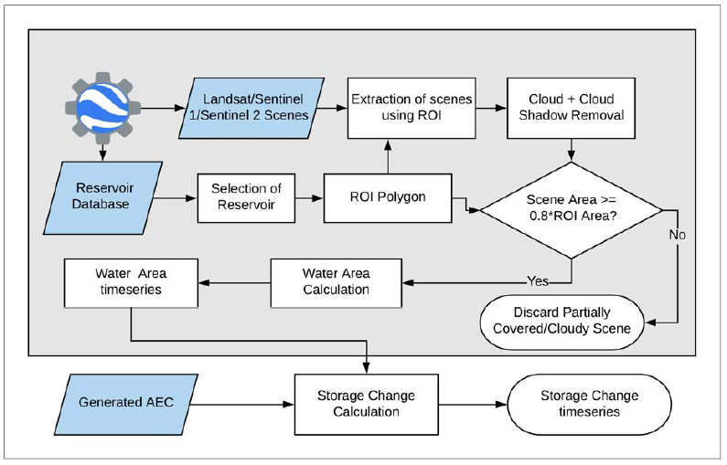

**Figure 3**: Surface water area time-series and storage change calculation workflow (source: Kumar Biswas & Hossain, 2017.)

**Surface water level extraction using satellite altimetry**

For an example, using the automation method developed by Okeowo et al. (2017), a time series of water level changes over the Nam Ngum 2 reservoir in Laos is generated using Jason-2 altimetry (**figure 4**). Among 31 reservoirs currently implemented in RAT, 16 reservoirs including the Nam Ngum 2 reservoir have at least one altimeter overpass. However, the skills of these altimeters over each reservoir need to be further examined. On the other hand, basaed on Okeowo et al. (2017), an open-source web application called *Altimetry Explorer* *(AltEx)* for Jason-2/3 altimetry over global inland water bodies has been developed by NASA SERVIR Coordination Office (SCO) (Markert et al., 2019) (**figure 5**).

**Figure 4**: Water level changes over the Nam Ngum 2 reservoir using Jason-2 altimeter data with 10-day interval.

**Figure 5:** Interface of Altimetry Explorer (altex.servirglobal.net)

**Storage change calculation**

The storage change time series was calculated from the surface water extent area time series and the AEC (figure 3). For any pair of consecutive surface water area data, corresponding elevations were computed from the AEC. Storage change was calculated from two consecutive heights and elevations using equation (2).

**Simulation of reservoir inflow**

The reservoir inflow was simulated using a hydrological model with streamflow routing capability. Variable Infiltration Capacity (VIC) model (Liang et al., 1994; Lohmann et al., 1998) was chosen for simulating the gridded surface runoff, evaporation, and baseflow in the upstream catchment area of the reservoir. 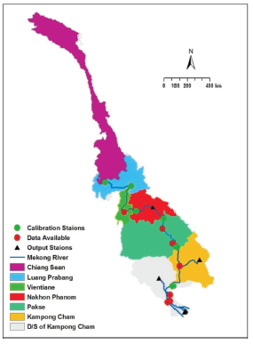

In-situ discharge data were available at 13 different locations on the Mekong river (**Figure 6**). At each location, the water (river) level data were available from 1985 to 2013, while discharge data were available from 1985 to 2005 in most stations. Thus, a flow rating curve at each station was developed to generate the discharge data from 2005 to 2013 (**Figure 7**).

**Figure 6:** Mekong river basin, showing the location of calibration stations with the additional stations where discharge data are available. Basin segment (i.e., sub-basin) of each calibration station is shown by different colours.

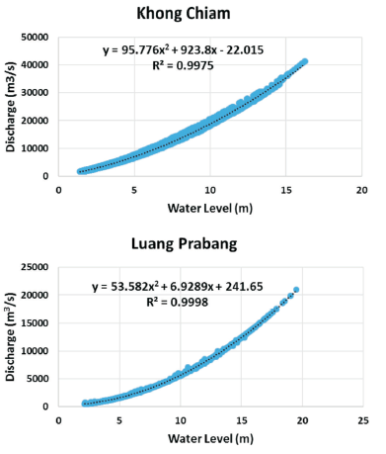

**Figure 7:** Sample of flow rating curves at two different locations on the Mekong river. (after Hossain et al.2017)

The VIC model was calibrated using four different soil parameters: the variable infiltration curve parameter (b inf); maximum velocity of baseflow (Ds max); fraction of Ds max (Ds) and soil moisture (Ws) where non-linear base flow occurs (Hossain et al., 2017). The model was simulated from 2002 to 2015. The output of the first year (i.e., 2002) was excluded to avoid any spin up error. The calibration period was set from 2003 to 2008, while the validation period was 2009-2013 (for the same six locations). The calibration and validation plots are shown in Figure 8. The error metrics of the simulated flow before and after calibration along with the validation period are shown in **Table 1**.

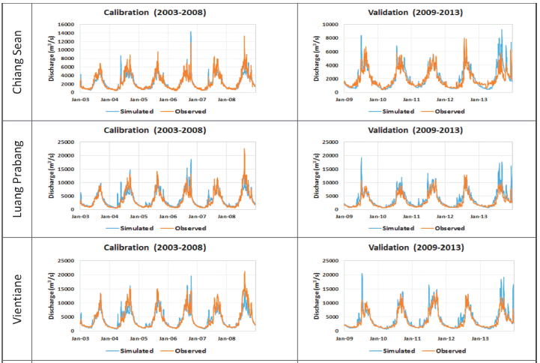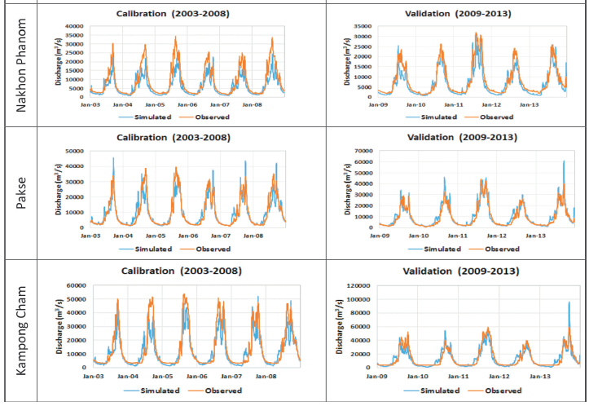

**Figure 8**: Calibration and validation plots at six different locations on the Mekong river. (Source: Chang et al., 2019)

**Table 1**: Performance metrics of the simulated discharge before (i.e., base) and after calibration. Validation is over the independent period of 2009-2013. NRMSE stands for Root Mean Squared Error (RMSE) of simulated flow normalized by observed flow and expressed as %. Efficiency pertains to the Nash-Sutcliffe measure. (After Hossain et al., 2017)

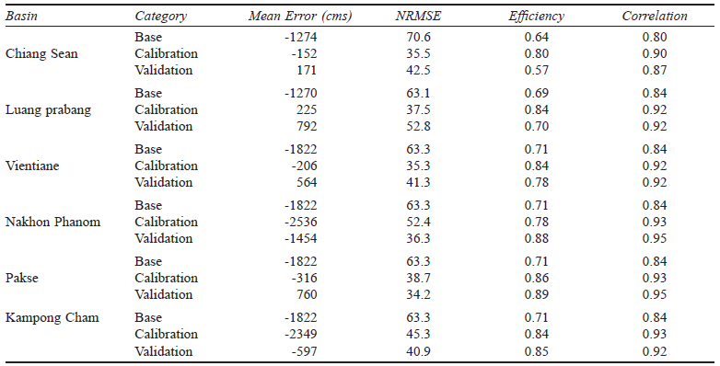

Note: Base (2003-2008) is the model efficiency before calibration; Calibration period is from 2003 to 2008 and validation period is from 2009 to 2013.

***Model* Validation *at Independent Locations***

In addition to the six stations that were used for calibration of VIC model parameters, there were four additional but completely independent locations where the model’s capability to simulate flow was tested (Hossain et al., 2017). **Table 2** and **Figure 9** summarize the flow simulation accuracy at these four locations (e.g. Chiang Khan, Mukdahan, Khong Chiam and Stung Treng). These locations provide a more robust test of how well VIC model can indeed simulate surface water availability patterns. When compared with the performance at calibrated locations it is very clear that VIC model can maintain a similarly high standard of skill in predicting flow at those locations at weekly to monthly scales needed for water management. We attribute this partially to the human regulation of flow by dams that the VIC model cannot simulate (see next section).

***Satellite* Observation *of Reservoir Behavior***

By applying the modelling technique based on mass balance and using satellite observables of reservoir height or surface area, the typical behaviour of the 17 Mekong reservoirs (dams) was identified according to Bonnema and Hossain (2016). Figure 8 reproduced from Bonnema and Hossain (2016) show how well satellite observations are able to capture the reservoir storage change, as an example, for the Sirindorn reservoir located in eastern Thailand. The good agreement with in-situ measurements indicates that the satellite observations (spanning visible, radar altimetry and passive microwave precipitation remote sensing) can indeed capture reservoir behaviour well at monthly to bi-weekly timescales and could be used to model the management component for physical models like VIC. Figure 9 shows the reservoir volume (normalized to capacity) for all the 17 reservoirs averaged over 14 years of satellite observation as an ‘effective’ rule curve.

**Table 2:** Performance of the simulated flow by VIC model at independent (non-calibrated) locations on the Mekong river

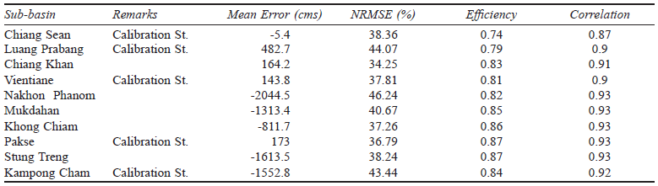

Analysis period: 2003-2013. See Table 1 for definitions for NRMSE and efficiency.

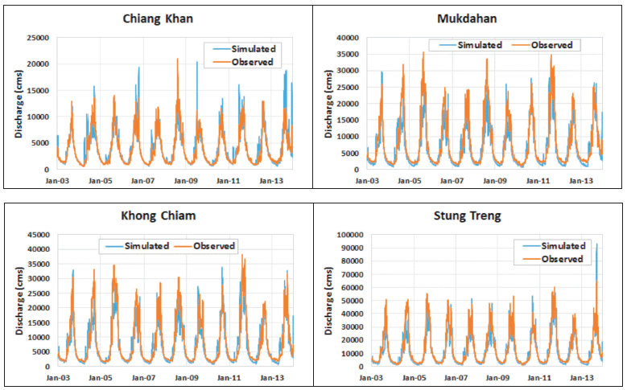

**Figure 9:** Validation of VIC simulated flow at locations not used for calibration. (Source: Chang et al., 2019)

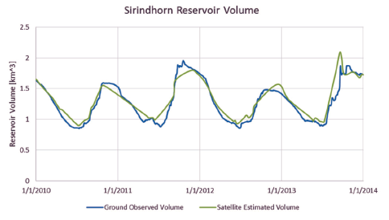

**Figure 10:** Comparison between ground observed and satellite estimated reservoir volume for the Sirindhorn Reservoir in Thailand. (Reproduced from Bonnema and Hossain, 2016).

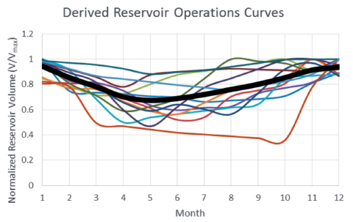

**Figure 11:** Derived reservoir operations curves (i.e. ‘effective’) for all 17 reservoirs, normalized by reservoir maximum volume. Average of all ‘rules’ shown in thick black. (Reproduced from Bonnema and Hossain, 2016)